**Week 1 Module 2.2 Assignment Flowchart**

Juan Macias Vasquez

Bellevue University

CSD325-H323 Advanced Python (2255-DD)

**Jack Lusby**

June 1st, 2025

Module 2.2 Assignment: Flowchart

Flowchart of From Intro to Programming with Python Module 4.2 Assignment

Miles To Kilometers Program

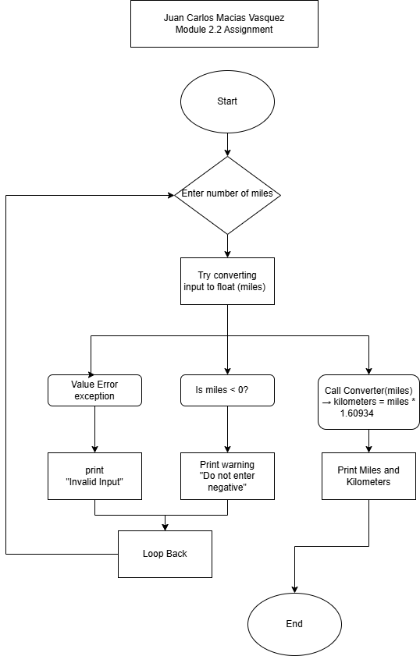

Made In Draw.io